Sustainable development challenges in suburban and rural China in the framework of economic transition. Learning and inspiration from best practices in France.

Keyword
Chinese suburban villages; economic transition; multifunctionality; design strategy; sustainability; linkage culture, agriculture and industry,
Author
Xu Danhua (PhD student @Zhejiang University, Guest researcher @TU Delft)
Wang Zhu (Professor @ Zhejiang University)

0 Introduction
With the cities’ prosperity of the Yangtze River Delta Area in China, the suburban villages in this area have also been influenced and developed the township enterprises by taking advantage of the geographic location and convenient transportation since the 1980s. In the context of relatively strict urban-rural migration on account of the urban-rural dual structure, the township enterprises provided the none-farm employment opportunities for the local surplus labors and then helped enhance the economic development and living standards in the past decades. Hence, quite different from those undeveloped villages in the middle and west parts of China, the suburban rural areas in the Yangtze River Delta Area enjoy a higher industrialization, showing the "situ urbanization" and diversification of population structure.
However, the suburban villages confronted with twofold dilemmas in the economic and human settlement. On one hand, the 2008 financial crisis had a heavy impact on the township enterprises with numerous bankrupts. On the other hand, the extensive industrial mode caused the environmental pollution reducing the living quality.
At the same time, the Chinese government proposed a policy of new rural construction in 2005 raising the requirements of industry development, well-off life, rural civilization, clean village, and democratic management. The policy encouraged the beautiful countryside movement of environment renovation, together with the optimization of the infrastructure system.
As for the suburban villages, if they only concentrate on the spatial beautiful movement, it will fail to overcome the development bottleneck and hardly achieve sustainability. The industry structure adjustment can’t be ignored and as urgent as the spatial design. So here is the research question: How can the suburban villages achieve a sustainable future by industrial adjustment and spatial planning in the framework of economic transition?
To find the answer, the theoretical evolvement in the rural development field will play a significant role in the first place, from which the suburban villages can find their orientation. Secondly, Bimen village will be analyzed in detail as a research subject to demonstrate the specific dilemmas in the suburban area in the framework of economic transition. Because the villages facing economic transition is a newly occurred phenomenon in China, it is hard to find a good Chinese example to learn from. When we turning to the International scope, the Ungersheim in France just achieved economic transition will provide good inspirations for China. After considering the insights from Ungershiem from the sustainable perspectives in the China’s economic-social context, Bimen village can generate the adaptive strategies of industrial adjustment and spatial planning to contribute to a sustainable future. (Figure 1)
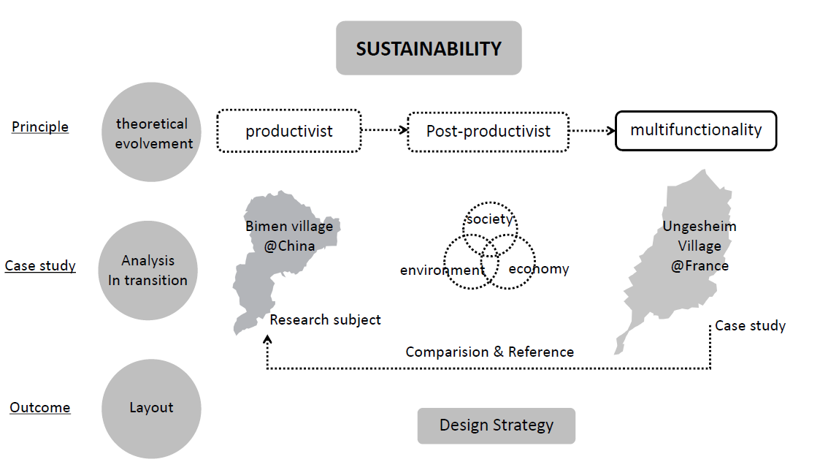
Figure 1 Methodology
Source：author

1 The theoretical evolvement in sustainable rural development
The notion of sustainability was triggered out from the conflict of the relationship between economic growth and environmental degradation in the environmental movement of the 1960s. Now it is widely acknowledged that sustainability is supported by the three pillars: environmental, social, and economic pillars. (R Hansmann, HA Mieg, P Frischknecht, 2012).
The sustainable notion influenced the shift from productivism to post‐productivism in rural developing principle.
After WWII，the European countries took the strategy of productivism which has been characterized by a central hegemonic position of agriculture in rural society (Cloke and Goodwin 1992), highlighting that productivist agriculture and food production occupied a special place in the ‘pantheon of traditional conservative values’ (Wormell 1978).
By the mid-1980s, the logic, rationale and morality of the productivist regime were increasingly questioned on the basis of ideological, environmental, economic and structural problems (Whitby and Lowe 1994). By contrast, a notion of post- productivism was proposed concerning consumption more than productivity. It is concluded five categories in the transition: (1) The shift from quantity to quality in food production; (2) The growth of on-farm diversification and off-farm employment; (3) Extensification and the promotion of sustainable farming through agri-environmental policy; (4) Dispersion of production patterns; (5) Environmental regulation and restructuring of government support for agriculture(Evans, Morris and Winter 2001 ).
However, with the different actions and thoughts in territorialization of productivist and post-productivist, many scholars began to question the utility of the dualistic notions embedded in traditional conceptualizations of productivism/post-productivism. It was argued that scholars exaggerated the claims of 'surplus' land in agriculture and a 'post-agricultural' future for the countryside (Halfacree, 1997). Wilson (2001) suggested that a multifunctional agricultural regime would be the endpoint of the post-productivist transition from the temporal dimension. Gradually Multifunctional agriculture has been accepted as a new paradigm for European agriculture and rural development (Huylenbroeck, Durand, 2003).
The shift of the theory is followed by policy and practice. With a better understanding of values in agriculture and village from the theoretical evolvement, EU adjusted the rural policy accordingly and contributes to the rural prosperity. Meanwhile, the suburban villages in China can find their orientation in the theoretical evolution as well. The multifunction epistemology emphasizing on both production and consumption is an ideal principle for them which mostly depended on the none-farm sectors. And the design strategies how to implement the multifunction theory will be proposed according to the detailed analysis of the case study and comparison of Bimen in China and Ungersheim in France.

2 Research subject: Bimen village
Bimen is a typical suburban village benefit from growing township enterprises and facing economic transition because of the finance crisis. Located in Anji County, Huzhou City, Zhejiang Province, Bimen village is 10 km away from the downtown of Anji County with a population of 1727 (Figure 2). Entrained east and west sides of mountains, Bimen lies in zonal distribution and occupies 10.1 square kilometers. In 1997, the road was broadened into provincial road No.04 and ran through the village and then it became the southern gate for citizens in Anji to reach Hangzhou, the famous tourist city and the capital city of Zhejiang province. Along the highway and provincial road, it only takes one hour from Bimen to Hangzhou by car at the distance of 56km. The per capita income grew up to 25,000 RMB (equals to 3420 euros) in 2014, which is 2.5 times of the nationwide average level, and the GDP reached 350 billion yuan (equals to 48 billion euros), which was regarded as a relatively well-off village.
In order to obtain the sustainable challenges of Bimen village, we conducted the analysis according to the three pillars of sustainability.
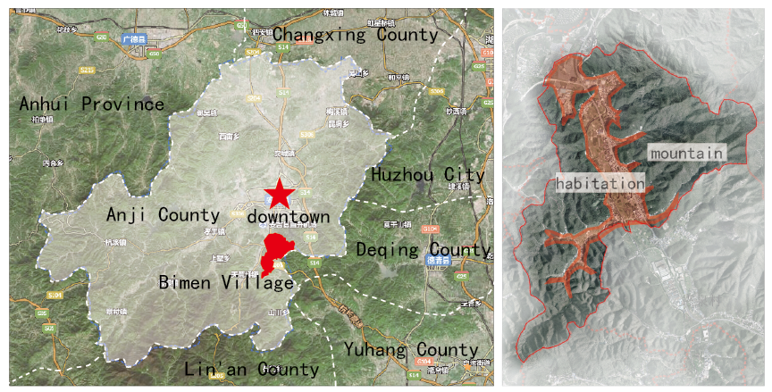
Figure 2 The Location of Bimen
Source：author

2.1 The economic pillar: industrial dilemma
As a suburban village, Bimen depends largely on non-farm sectors from the view of industry structure. 98% labor force were engaged in bamboo proceeding industry for the rich bamboo forests covering 67% of mountains reaching 522.7ha. Meanwhile the farmland owned the rural collective is contracted to outsiders to operate as vegetable greenhouses and vineyards. In addition, the tertiary sector is still at the initial stage with only one household catering the dinner service.
Bimen village is consistent with Anji County in the bamboo-industry-centered economic structure. Anji County, as one of China's top ten bamboo Townships, has developed the bamboo processing industry as the economic mainstay taking up more than 60% of GDP with the encouragement of the policy ever since the 1970s. Simultaneously, since Taiwanese enterprises stationed in the 1990s, Bimen village has developed bamboo processing industry for over 20 years, which provided the job opportunities for the local and helps achieve economic boom. The family workshops began to spring up in 2000. At present, there are 13 big-scaled enterprises and more than 130 family workshops taking on bamboo processing industry, with the annual output value reaching 310 million (equals to 42 billion euros), as the leading industry. The main products such as bamboo mat and disposable chopsticks, are low-technique in the primary process, mostly exporting to the oversea market involved in the global economy.
However, the financial crises in 2008 impacted the village greatly. The market of its main products which own low-added value declined sharply. For insistence, with the popularity of high-tech alternative option of air conditions, the demand of bamboo mat decreased dramatically. Moreover, compared with Bimen village in the developed Yangtze River area, other villages in less developed areas obtained better access to the market for lower labor costs. In a consequence, Bimen villages encounter the development crisis, with a number of family workshops and factories going bankrupt.
In terms of sustainable development, the economic structure needs to adjust to a sustainable growth by excavating the multifunctional value of the rurality.

2.2 The environment pillar: nature and settlement
In the nature aspect, the Bimen village built on the area between the eastern and western hills which are reserved without construction activities, can enjoy the beautiful view of bamboo mountains. The river passing by is under the dredging engineering.
In the human settlement aspect, the basic infrastructures requirements of villages can be met while the public service facilities are still lacking and in uneven distribution. It shows two main features in the spatial perspective.
a. the feature of spatial planning and architecture design
For the absence of overall spatial planning, Bimen village is easily influenced by the upper-level planning in a top-down way. In the province road No.04 construction project, the road is broadened to 16 meters, leading to the demolition of 15 households (Figure 3). Their resettlement area set in previous farmland was designed in lines and rows, different from the previous context.
Most of the present dwellings were newly built single houses in reinforced concrete structure between 1980 and 2000, and meanwhile the old housings built in the 1950s were almost already torn down for the new houses. The locals need to apply for the construction land from the village committee and conduct self-establish buildings without any control or guidance of the features and styles. In the consequence, the American style houses win the most favor of the locals regarded as a symbolization of wealth. Therefore, the characteristics of the ancient architecture seldom can be found (Figure 4).
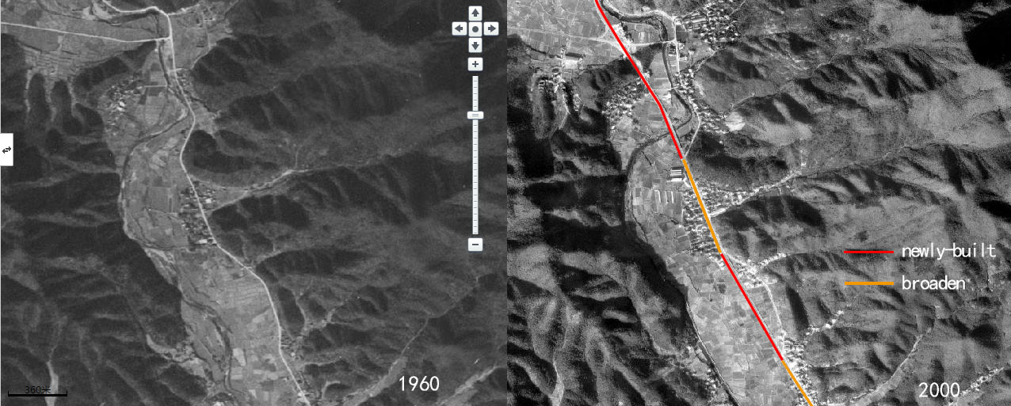
Figure 3 the province road No.04
Source：author

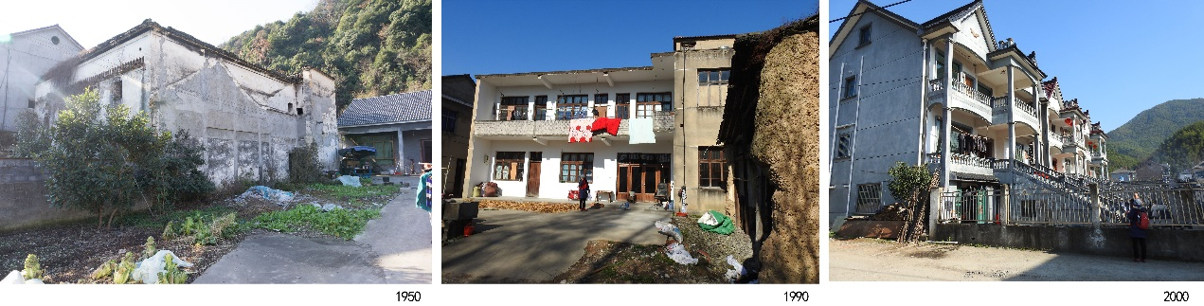
Figure 4 The chronologic building styles
Source：research group

b. the industrial influence to the spatial environment
Since the bamboo industry deeply penetrates into the daily life, there is a high proportion of dwelling mixed with the workshops (Figure 5). The temporary structures taking up the court affect the daylighting and ventilation. Moreover, since 2005, the illegal structures has occupied the public open space impacting the village appearance. What’s worse, in the case that the environmental protection law was not so strictly performed, the industrial waste was piled up at random seriously damaging the landscape and even causes ecological pollution, while the abandoned factories showed a state of decay.
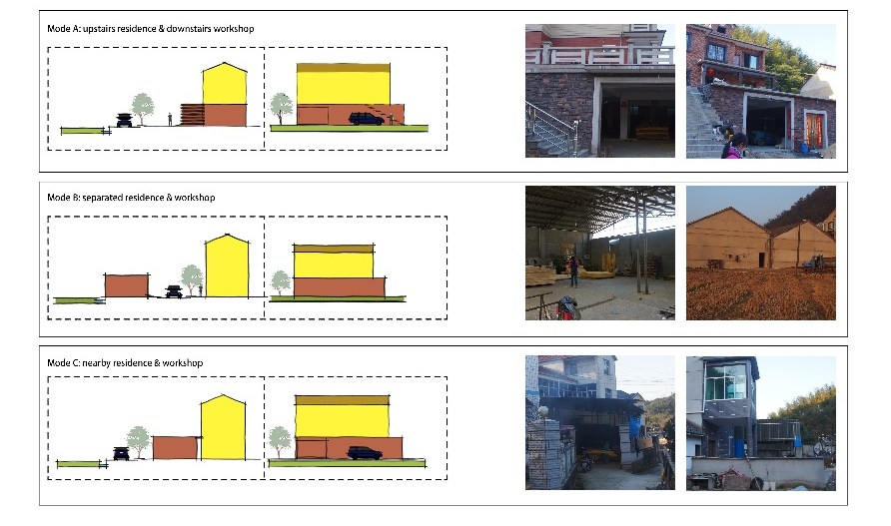
Figure 5 mix-use type between housing and workshop
Source：research group

2.3 the social pillar: opportunity
The local enterprises including the big scaled ones and the family workshops attracted the most surplus labor. Besides, the convenient location also made it easy for locals to commute if they work in the city center. Therefore, the population is gradually growing without the rural exodus problem.
In 2014, Bimen village was placed under Lingfeng Town governing the Bamboo Expo Garden who owned great reputation and achieved prosperous tourism. Hence, Bimen village burdened the government’s hope to develop rural tourism by taking advantage of its transportation and surrounding resources in need of the economic transition.

To conclude, Bimen village confronted twofold dilemmas in both economic and environment and also has the opportunity from government support. If the rural planning and design strategies fail to take the industry transition into account, the spatial planning would help only a little at the moment and could hardly contribute to sustainable future in the long run. From the following case study of Ungersheim village in France, we try to learn the specific design strategies both in industrial and spatial planning and adjust them to the Bimen village in the Chinese context.

3 Case study: Ungersheim in economic transition
Ungersheim is located in the Alsatian region, the northeastern France. In spite of the big differences in rural development situation between China and France, there still exist some similarities. In the first place, both China and France are big agricultural countries. Half of the France territory belongs to farmland and three-quarters population live in the rural areas, while the urbanization rate just reached 57.35% in 2016. Secondly, Compared to other developed economies in Europe, France’s urbanization process is relatively late, and a phenomenon of rapid urbanization occurred during 1950-1970 reaching an average annual growth rate of 1.25%( Figure 6), while China achieved 3% in the last decades. Therefore, they will confront with similar developing dilemmas. Last but not least, the top-down planning mode occupies such an important role in these two countries with a relatively centralized government that how France reacted according to the paradigm shift of the rural development will provide a reference to China.

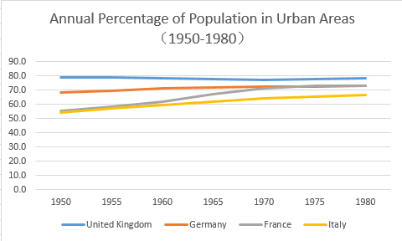 | 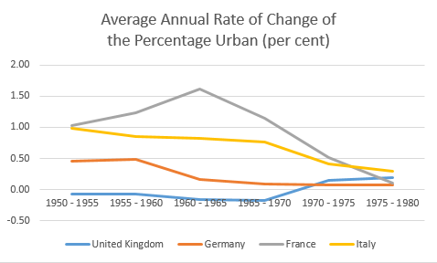
Figure 6 Urbanization changes in 4 countries of European
Source：United Nations, Department of Economic and Social Affairs, Population Division (2014)

As to the case Ungersheim village, it also shares lots of similarity with Bimen village in the area, population and transportation advantage with Bimen village.Ungersheim is 15 kilometers from Mulhouse the second largest city in the Alsatian region, covering an area of 13.51 square kilometers with a growing population to 2094 in 2014. Nearby there is the Little Prince Park and the Eco-Expo Museum.
With rich potash mine, Ungersheim has a long history of mining and once hired 13,000 people in the local. However, in 2003, the last one mine is closed. In the context of energy and economic transition, Ungersheim began to explore a sustainable approach. Under the leadership of the mayor and the government, 21 reform projects were carried out in the following three categories:

3.1 economic strategy: from mining to green industry
Ungersheim made emphasis on the organic agriculture, solar energy and tourism, taking advantage of the multifunctional village (Figure 7).
Firstly, 8-hectare farmland was transformed into organic farming which is completely pesticides prohibition employing 30 people. It produces 64 varieties of vegetables, provides 300 baskets of food for local families every week. At the same time, the local primary school is served 100% organic meals every day including snacks. Then they start a food preservation business, canning locally produced food so as to extend its availability.
Secondly, Ungersheim shift from an energy-consuming village to an energy-producing one. The former waste mining site transforms into a 5.3MW power solar energy industrial park.
Lastly, the service sector depends on the Little Prince Theme Park and the Eco Museum. The eco Museum is an open air museum where authentic Alsatian buildings have been transferred and reassembled as a living village. The abandoned mining factory was also included by the eco-museum as the industrial heritage exhibiting the machines, factory and mining life.
Figure 7 The industry transition of Ungersheim
Source：https://www.mairie-ungersheim.fr/village-en-transition/

3.2 Spatial strategy: an environmental-friendly approach
Because of the scattering distribution of mining industry and housing, the landscape of Ungersheim is still in good condition. What has been done to improve the human settlement is a low-carbon approach influenced by the multifunctional notion. The reuse of abandoned mining field and factory by functional replacement to solar panel industrial park and part of Eco-museum takes full advantage of the existing resources. Moreover, they assessed all public buildings for their energy consumption, and encourage to reduce carbon emissions in construction and use of buildings. To achieve this, passive energy-saving buildings, intelligent low-carbon lighting systems are applied. The new co-housings are south-facing, local timber-framed, made with pre-manufactured straw bale panels, with a communal solar hot water scheme and shared gardens, which are built at an affordable price and in a passive energy saving way (Figure 8).
Figure 8 The new co-housings
Source：dea-architectes;https://transitionnetwork.org; http://www.modcell.com/

3.3 Social action: bottom-up community movement.
Actually the changes happened in Ungersheim are largely conducted by local community supports by the major and authority encouraged by “transition” movement, launched by Rob Hopkins, which connects places evolving to a more sustainable model and looking for a growing independence to fossil fuel through the efforts of locals. Therefore, participative democracy can be easily observed in the process of transition. For instance, the community hosted a forum about renewable energy and campaigned for the closure of the Fessenheim nuclear power station. In addition, the frequent discussion and meeting on the new dwelling design among the architects, professional builders and each household made it possible to satisfy the diverse personal demands. Furthermore, the organic farms shorten the distance between the growers and the consumers, which is a sustainable agricultural mode, also provided the local unemployed youth the chance of training and getting access to resources. In such a bottom-up collaboration between diverse stakeholders, the projects can be carried out to meet wide satisfaction.

4 Reference analyses
The successful transition of Ungersheim from a mining village to an eco-village is based on the foundation of the economy, institution, eco-system and administration in France. Despite the great differences between China and France in the agriculture modernization, rural development policy, environmental protection laws and decentralization, it is still worthy for the suburban village in the most developed area of China which has a better potential to achieve sustainability to obtain some practice references from France. In the framework of transition, the insights adjusted into local context from the 3 pillars of sustainability will form the specific strategies to guide the villages to practice according to the multifunctional theory.
 | Ungersheim | Bimen village
economic | - Shift from mining to multi-sectors of organic farming, solar energy, tourism  - Low carbon sectors | - Bamboo industry dilemma in smaller market and low profit  - Farming only for production  - Little service sector
environment | - Scatter distribution of industry and residence  - Low carbon building  - Reuse the mining field and factory | - Temporary structures take up public space  - Pollution from bamboo processing  - Mixture of workshop and dwelling
society | - Bottom-up and active community support  - government support  - growing population | - Top-down planning system  - Lack of awareness of public participate
Table 1 Comparison between Ungersheim and Bimen village (Source: author)

4.1 The economic pillar: industry structure adjustment
The fact of transition from the mining industry to a multifunctional structure combining organic agriculture, solar energy and tourism of Ungersheim makes Bimen village to reimagine its industry structure. Need it abandon the existing bamboo industry like Ungersheim or upgrade the structure system in another approach? The answer to the question should take the local context into consideration.
Firstly, bamboo as a kind of renewable resource has a big potential to seize the market if it is manufactured into innovative and high-value added products through industry upgrade. Secondly, the bamboo enjoys multifunctional values such as landscape, culture and the handmade bamboo processing can attract experiential consumption according to the multifunctional theory. The development of the new kind of bamboo industry will in return contribute to the rural tourism as a unique and local characteristic, living up to the government’s expectation. In addition, the farmland can also develop into art farming with sightseeing and picking tourism, a balance between productivism and post‐productivism. The advantages in the transportation, location and government support lay a good foundation for its multifunctional development.

4.2 The environmental pillar: reused space and multifunctional industry landscape
Because of the distanced relationship between industry and residence, the landscape of Ungersheim remains a beautiful countryside scenery. After the transition, the previous mining field and factory are given new functions and even treasured as industry landscape for exhibitions. By contrast, the mix-use of workshop and housing is the main problem in Bimen village, which is more complex closely related to the industry development.
According to the economic transition and industry structure adjustment strategies, the spatial planning can be clear to reuse the space and transform the industry into the landscape. The transformation can be conducted in the overall, factory and family workshop aspects.
In the overall scale (Figure 9), the temporary structure and the rubbish yards of the workshop which impact the living environment should be demolished and cleaned selectively through reasonable assessment. The released space can be replaced by public space, green space and social communication space and then shape the public space system.
Figure 9 The overall planning strategy
Source：research group

For the big factory (Figure 10), take a different strategy based on the quality condition of buildings.
(1) OT (Operation, Transfer): For those still in good condition, it is a wise choice to bring in appropriate functions and renewal as well as upgrade the surrounding environment.
(2) ROT (Rehabilitate, Operation, Transfer): For those in general quality condition, repairing the structure, updating features and renew the facade are what needs to do.
(3) BOT (Build, Operation, Transfer): for those in bad-quality condition, proposals of demolition to be local public open space or reconstruction to be a new building should be adopted.
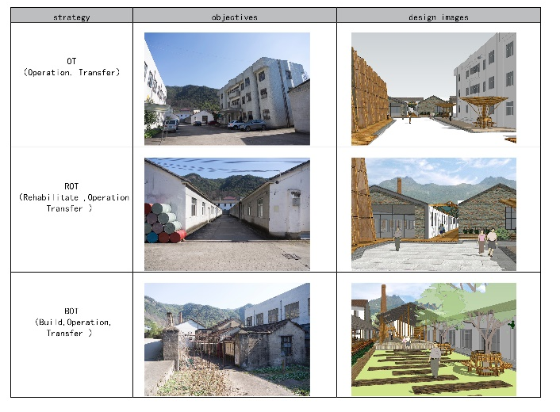
Figure 10 The factory reuse strategy
Source：research group

As to family workshops (Figure 11), the renewal guidelines are diversity according to the classification of the types. Firstly, solve the problem of light and ventilation to meet the basic requirement of the physical environment. Secondly, design a new type of mixture of family and workplace by using bamboo details, creating the atmosphere of bamboo culture. By doing so, the industry can also be a kind of landscape, catching the visitors’ attention to visit, even experience the bamboo processing and enjoy other services.
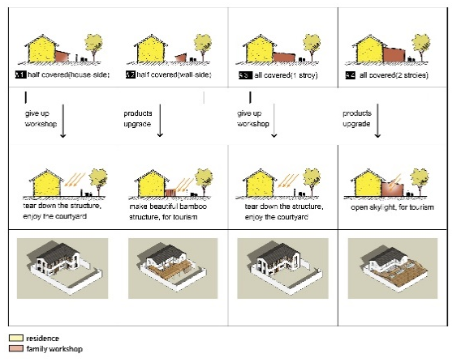 | 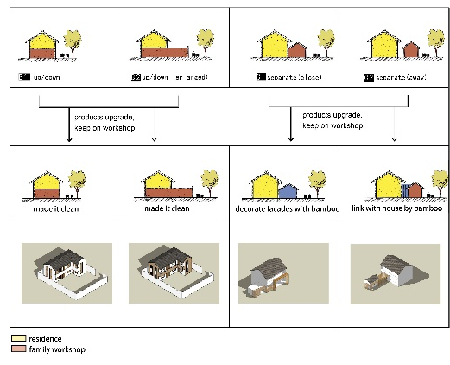
Figure 11 the renewal guidelines of family workshops
Source：research group

4.3 The social pillar: Public participation
In the process of transition in Ungersheim, public participate is one the most extraordinary factors to achieve an eco-village. The strong awareness and active participation of the community are quite impressive, especially compared with the weak consciousness and short-term scope of the villagers.
While the Chinese typical top-down planning mode makes it efficient to achieve the projects with policy and finance support, it needs more and more requirement for public participation in the fine design of the micro-space. In the planning process of Bimen villages, some important village cadres who know the local demands better get involved in and propose several suggestions, which is still on a surface level.
In future, it is of vital importance to make all stakeholders involved in the rural construction process and mobilize their enthusiasm actively which is a bottom-up approach. To start with, listen to the needs of the villagers, encourage the rationalization of industrial development and raise their awareness of protecting environment spontaneously. Secondly, organic farm owners have the chance to promote themselves on the Internet and attract online consumers to the scene and appeal to citizens to build community-supported agriculture by consuming, investing, participating and volunteering. Thirdly, the introduction of innovative bamboo-producing enterprises will improve the technological content of local industries and provide technical training and job opportunities for the villagers. Meanwhile, nearby universities can serve as intelligent consultants to provide advisory services for the whole rural development. Last but not least, it is the Government’s responsibility to establish a democratic decision-making platform, and give policy financial support simultaneously. Obviously, China has got a long way to go.

5 Conclusion
In the framework of economic transition, most of the suburban villages in the Yangtze River Delta have influenced by the economic crisis and the overall market downturn. The twofold dilemmas both in economic and human settlement grow distinctly. Despite the unique urban-rural problem China owns for its big scale and complex history, the insights from the shift of the rural policy in European countries according to the different phases can still work. China can benefit from the lessons and discussions on productivism and post-productivism and choose a multifunctional approach by balancing them both according to national conditions.
From the detailed analyze and comparison between the Chinese and French village cases, China’s rural construction can acquire inspirations in the 3 pillars of sustainability.
- Economic level: economic development is the base of the rural area and a reasonable industry planning is the primary key. The theory of multifunctional village gives the rurality a new perspective to view the value itself with a potential combination of art agriculture, handcrafts, rural tourism and so on.
- Environmental level: the landscape is the main value of the villages especially compared with cities. The current beautiful movement is concentrated on spatial renovation, the demolition and reconstruction, which is easy to see the effects. However, an overall systematic and real helpful spatial planning needs to coordinate with the industry planning, meaning more time, energy and fund consuming.
- Social level: with rational industrial and spatial planning and practice, the attraction and cohesion of villages will be strengthened to a large extent. The previous top-down planning mode contributes to the village construction a lot. However, the public participation will be the main trends in the fine design with the rise of the villagers’ awareness and education level. All the stakeholder will need to learn to work together to fulfill the projects’ implement.
In summary, to deal with dynamic changes in the market and constantly improving living requirements, it is urgent for villages to seize their resources and history to propose resilient economic-oriented planning strategies. The flexible proposals will contribute to the revival of rural economic development, ensuring the stability of the social structure and finally achieving sustainable development in society, economy and environment in rural areas of China.

Bibliography
https://transitionnetwork.org/stories/ungersheim-village-transition-france/
Epstein, T. David Jezeph. Development-there is another way: a rural-urban partnership development paradigm, World Development, no.8 (2001): 1443-1454.
Evans, Nick, Carol Morris, and Michael Winter. "Conceptualizing agriculture: a critique of post-productivism as the new orthodoxy." Progress in Human Geography 26.3 (2002): 313-332.
Fei Xiaotong. The village reconstruction, Changsha: Yuelu Press. 2012
Gan Ping. Research on optimization of bamboo industry Chainofanji county, Master diss., Anhui University of Finance and Economics, Bengbu, 2015
Gu Min. The research on transformation and upgrading policies of Anji bamboo industry under the background of beautiful village construction, Master diss., Ningbo University, Ningbo, 2015
Hansmann, Ralph, Harald A. Mieg, and Peter Frischknecht. "Principal sustainability components: empirical analysis of synergies between the three pillars of sustainability." International Journal of Sustainable Development & World Ecology 19.5 (2012): 451-459.
Hu Yi, The Discussion on socialism new countryside development patterns. Master diss., Guangxi University, Nan Ning, 2007
Haines, AL. An innovative tool for managing rural residential development: a look at conservation subdivisions, the Land Use Tracker, spring 2002.
Ma Ning.Study On the evolution model of peri-urban rural in the new era- a case study of southern jiangsu areas. Master diss.,University of Dongnan, Nan Jing, 2006
Van Huylenbroeck, Guido, and Guy Durand. "Multifunctional agriculture: A new paradigm for European agriculture and rural development." (2003).
Wan Baorui. Zhong Guonong. Thinking and outlook of china's agricultural development, Beijing: China Agriculture Press,2006
Wang Zhu, Qian Zhenlan. ‘Shaoshan Experiment’ exploring methods for constructing economic-social development oriented rural human settlement, Time Architecture,no.3 (2015): 50-54
Wang Zhu, Qian Zhenlan. Concepts and strategies of organic renewal of rural human settlements. [Journal of human settlements in west china, no.2(2015):15-19
Wilson, Geoff A. "From productivism to post‐productivism… and back again? Exploring the (un) changed natural and mental landscapes of European agriculture." Transactions of the institute of British Geographers 26.1 (2001): 77-102.
Yuan qianyan. The tourism city’s suburban countryside economic development decision research, Master diss., Beijing University of Technology, Bei Jing, 2012
Zhang Lixiang, Eight kinds of modes for new villages’ reference, Chinese Township Enterprise,no.3(2007):62-63

