Blue Heart: the Evolution of a Wet Rurality in Holland
Claudia Bode, MIT

HYPERMANAGEMENT
In Holland (specifically, the provinces of North and South Holland in the Western Netherlands), rurality as well as urbanity are intimately associated with the hyper-management of the land. Over centuries, the Dutch created a vast network of pumps, sluices, ditches, canals and other technological monuments that carved dryness out of what had originally been marshy peat, allowing for farming and the development of extensive trade networks. The technologies that created Holland can be read in the grammar of the landscape itself, with regional networks of water transport and storage (canals, ditches, lakes), punctuated by pumps (windmills, pumping stations), reflected in the plan layout of polders, farms, villages and cities. To walk along a simple ditch that separates two farms is to walk along the smallest element of a sophisticated infrastructural network that moves and stores a vast amount of water every day of the year; without constant monitoring and pumping, Holland would already be underwater. It was the need to work together to pump water out of fields that led to the birth of the democratic “polder” system, still a model for Dutch politics.
It is difficult to define “nature” in Holland given that every inch of the land has been extensively manipulated. Those wild zones that exist (for instance, the Biesbosch) are not areas that have never been touched, but rather places of technological exception or failure. The words “rural” and “urban” become confused as well, since both Dutch cities and Dutch rural areas were shaped out of the same necessity to stay dry and are dependent on the same technological systems of water pumping, transport and storage. Even the rural economy typical to Holland – dairy farming – is found here because of a technological feedback loop: centuries of pumping dried out the peat-based earth, which evaporates when it is no longer wet, leading to extensive subsidence and the need for even more powerful pumping to prevent flooding from rivers which are now higher than the surrounding land. In order to slow down subsidence, the groundwater levels in the peatlands are kept as high as possible, which makes it impossible to grow crops. The alternative is family dairy farming, since grass does grow readily in waterlogged soil.
The hyper-management of the landscape in Holland emphasizes the connection between urbanity and rurality and the poverty of the words we use to describe these two conditions. Holland is a manufactured, technological landscape, and this includes its cities as well as its traditional rural areas.

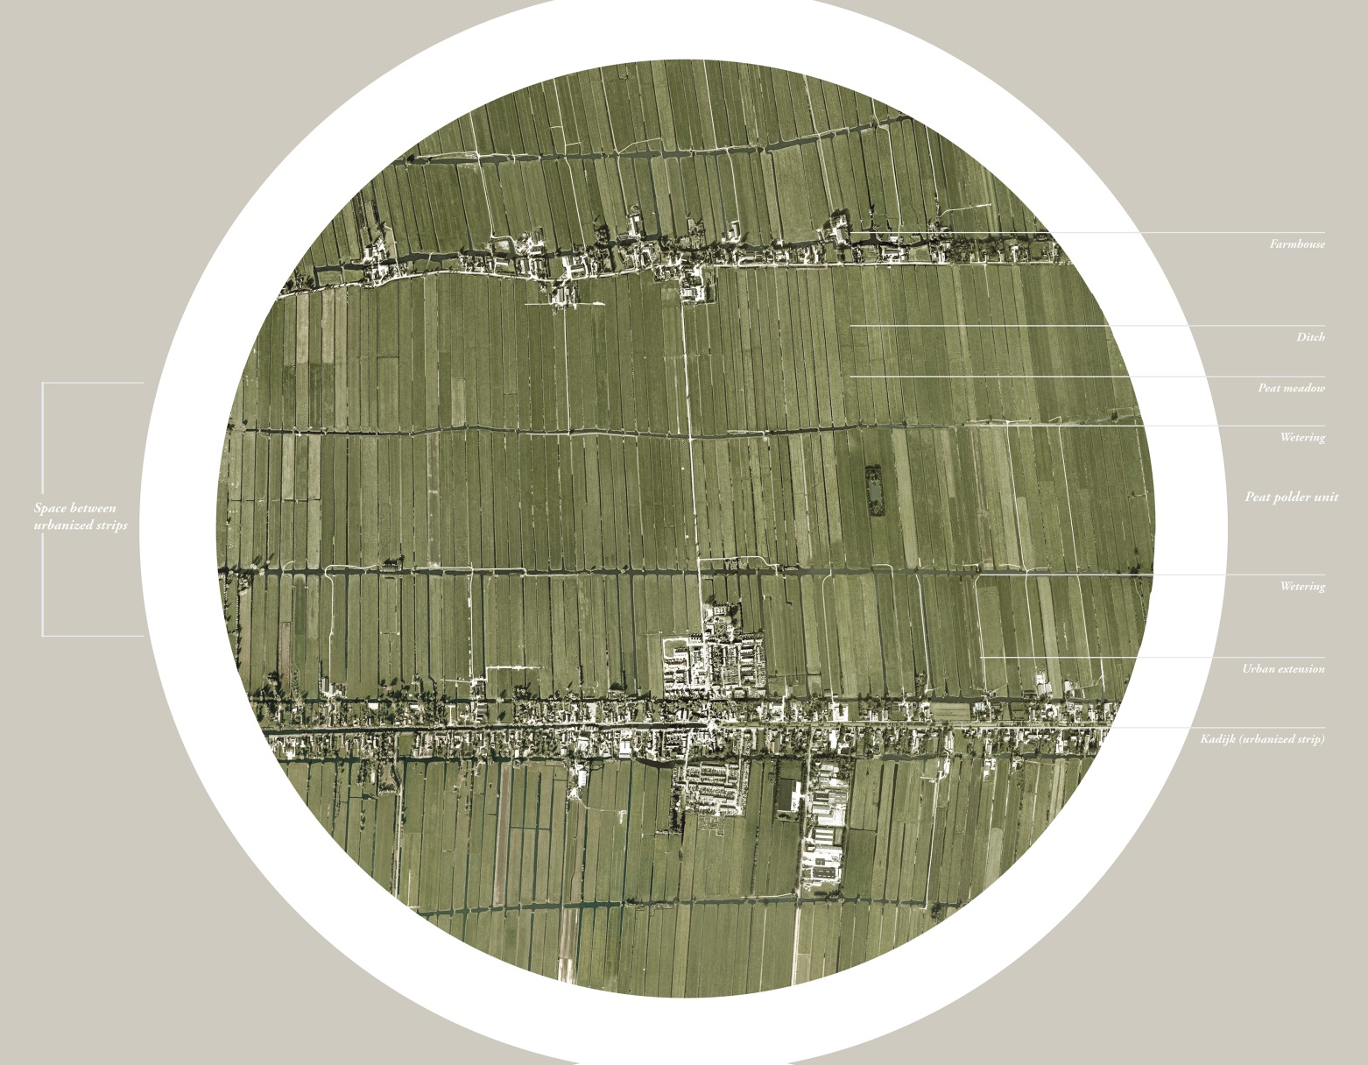
Image. 1: Existing peat polder “landscape grammar”

A CONVENIENT LANDSCAPE IMAGINARY
This history of water management in Holland has created an enduring landscape imaginary. Golden Age paintings show canals, windmills, barns and cows and other features of rural life with a great deal of precision and realism; today, a Google search for “Dutch landscape” will produce modern versions of the same images in the form of advertisements, photographs or stock photos. Clearly, the Dutch landscape and its forms resonate on a cultural or semiotic level: those infrastructural elements that are so critical to keeping the landscape dry also serve as its signifiers. Critically, they also serve to justify the growth of the opposite: the poly-nodal city called the Randstad.

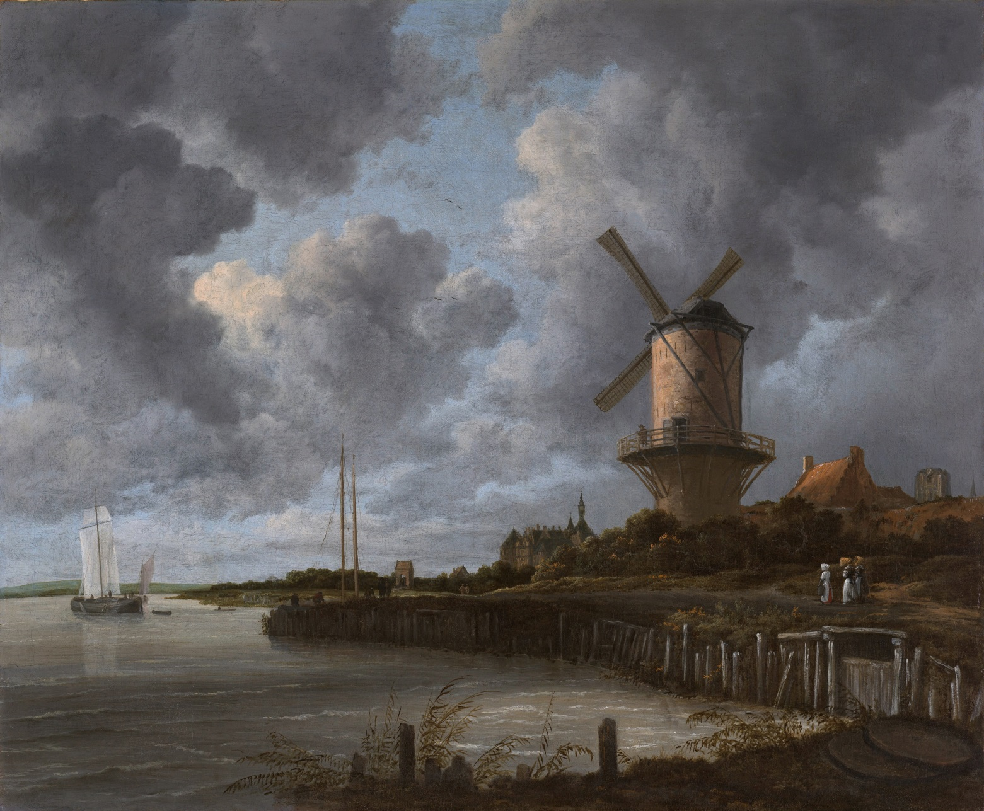
Image. 2: Die Mühle von Wijk bij Duursted, Jacob van Ruisdael, 1670
The Randstad is a term that was invented in the 1930s by the then-director of KLM Airlines, Albert Plesman, who was trying to convince the Ministry of the Interior to build one national airport instead of three local airports. At that point the idea of one interconnected city was a stretch of the imagination, because the major Dutch cities (Amsterdam, Rotterdam, The Hague and Utrecht) were still quite separated from each other; however, in the next decades they did become significantly interlinked. Randstad literally means “edge city”, and the term is a conceptual sleight of hand that allows this interconnectedness to happen without allowing the region to turn into a megalopolis.
Since the middle of the twentieth century, the romanticism of the Dutch rural landscape has provided a justification for the growth of this city around it. The concept of the Green Heart, with its windmills, canals, herds of cows, and traditional farmhouses came into being as a response to the problem of the Randstad; it is the green void that provides the “edge” around which the city is allowed to grow. The identity of the Green Heart is intimately linked with the identity of the Randstad: when the political climate favors an integrated Randstad, it favors an integrated Green Heart. When the political winds blow towards diversification, the Green Heart also becomes less unified. The more the Randstad grows, the more valuable the Green Heart becomes.
In the hyper-planned context of the Netherlands, traditional rurality becomes utilitarian; the technological forms of the Green Heart resonate in the semiotic register to create economic value. The myth of the Golden Age pastoral landscape is maintained, encouraged, protected - if only to allow it to continue serving as counterweight to the city.
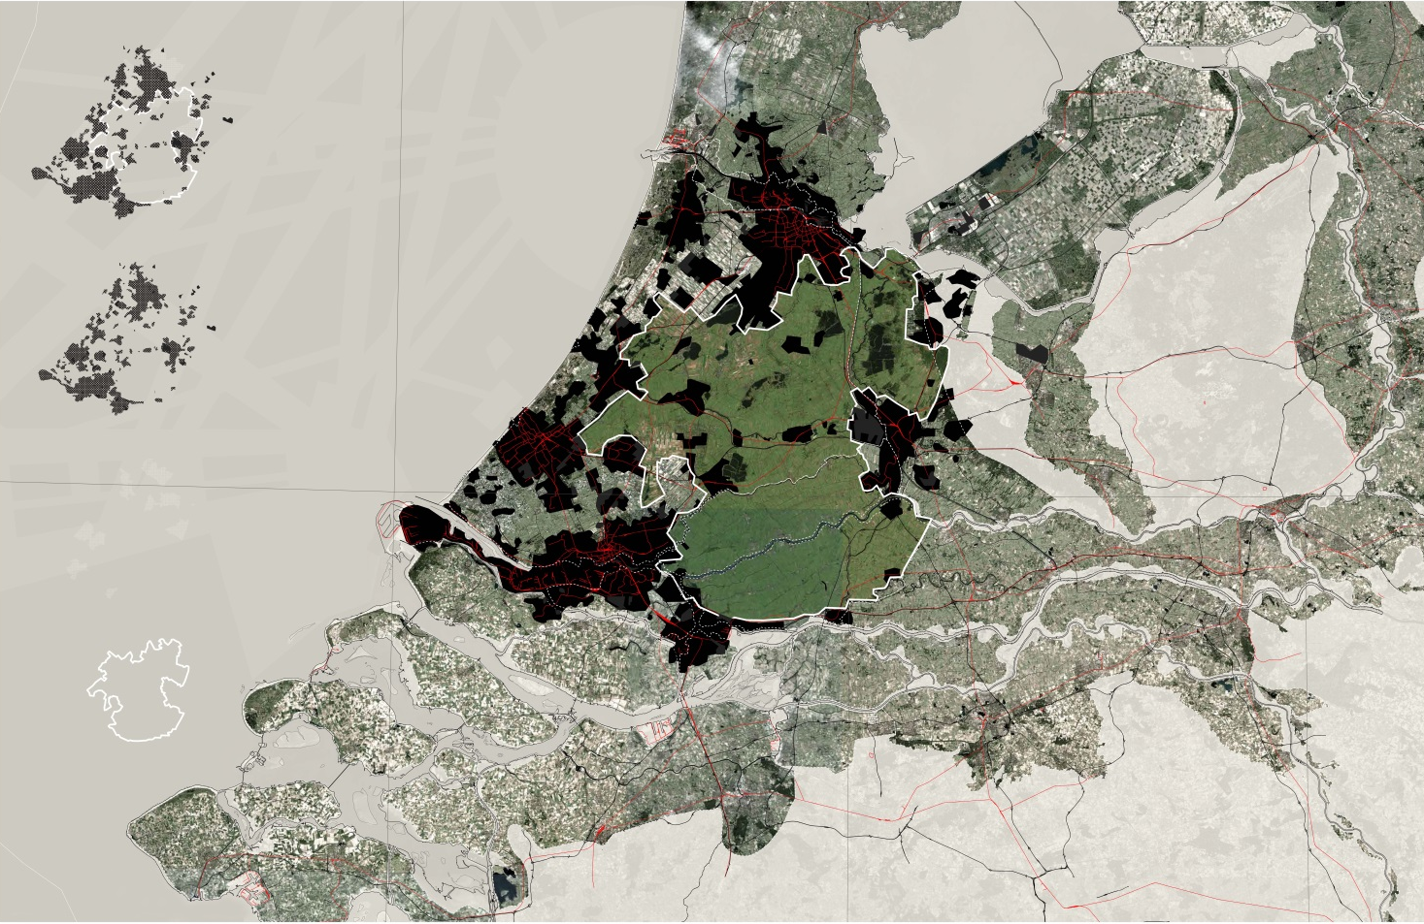
Image. 3: The Green Heart in the context of the Randstad

GREEN HEART CRISES
Even as the ideals of Dutch rurality continue to influence Holland’s image of itself and its mechanisms of urban planning, they are becoming increasingly disconnected from environmental and economic realities. Much of this is related, unsurprisingly, to water: as the climate changes, increasing amounts of water and frequency of flooding events from the Rhine-Meuse river system threaten to overload Holland’s boezem system, the network of water storage sites that acts as a sponge to protect low-lying urban areas from riverine flooding. At the same time, the medieval peat polders (the most traditional and rural areas of the Green Heart) are subsiding so quickly that even dairy farming is becoming difficult in many areas - in some areas the groundwater level is only 40cm below the ground, and many plots are effectively floating. Both of these issues make it clear that the Green Heart, despite its historical and semiotic significance, must urgently become wetter both to fulfill its role as Holland’s protective sponge and to prevent continued subsidence.
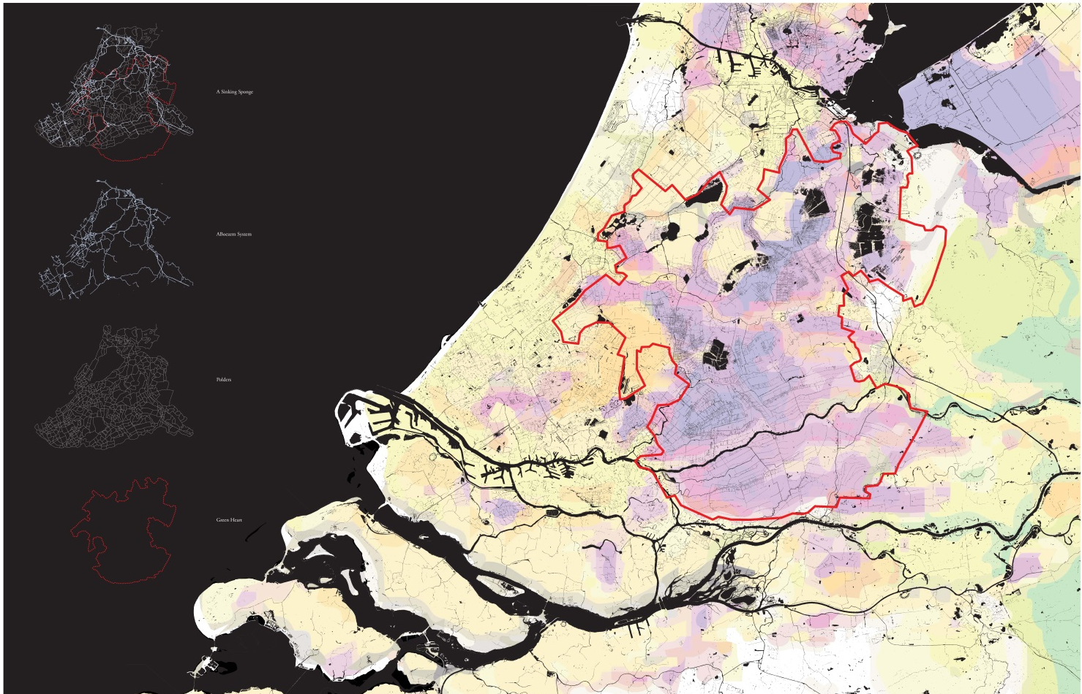
Image. 4: The Green Heart corresponds to areas of Holland which are subsiding fastest.

At the same time, economic realities and increased globalization make it increasingly difficult for traditional small dairy farmers to remain in business. In 2015, the EU liberalized the dairy industry, accelerating a process of consolidation which had already been underway. Despite planning regulations that seek to limit non-agricultural land uses, the character of rural areas in Holland is already changing, with yoga retreats for young urbanites popping up next to increasingly large corporate dairy farms.
The Dutch have the technological resources to adapt to these new realities, but what remains to be seen is whether the fundamental character of rural Holland will remain the same when faced with such transformative change. Can the Dutch landscape imaginary survive? Perhaps the more important question is: should it? Perhaps the crises facing the Green Heart are in fact opportunities for projective speculation about the future of the rural Dutch landscape.

FROM GREEN HEART TO BLUE HEART: A LANDSCAPE PROPOSAL
The Blue Heart is a speculative landscape proposal that creates the space for new paradigms at the architectural and urban scales. It takes as a given the need for increased wetness of the Green Heart landscape (through the strategic expansion of the boezem water storage network) and asks: how could these new environmental realities create new social, ecological, economic opportunities? Can a crisis become a new beginning? At the same time, the Blue Heart opens up the space to examine critically the existing Dutch landscape imaginary. Can old forms survive? What are new myths, new images?

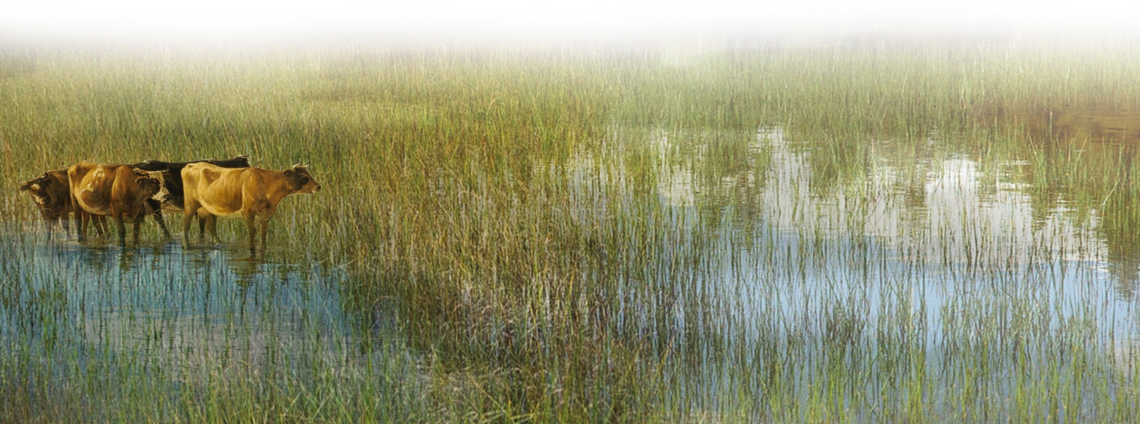
Image. 5: The Blue Heart: towards a soggy rurality

Take the Krimpenerwaard as an example: this is the fastest subsiding zone in the Green Heart and a typical example of a medieval peat polder landscape. Weterings (large canals) run almost parallel to the two large rivers that surround the island, between strips of farmhouses along original kadijks (urbanized canals) and along the river banks. The kadijks terminate in a number of small villages. Many parallel ditches run perpendicular to the weterings, dividing the land into long strips of roughly equal width. Several small towns are found on the farmhouse strips, and on the north side boezems extend from the river into the fields. Several original peat streams also cut through the landscape, recognizable by their meandering form.
At the landscape scale, the Blue Heart proposal calls for a strategic widening of existing waterways that is based on an analysis of this peat polder “landscape grammar”; these new widened waterways then serve as flexible storage zones for water (new boezems), slow down subsidence by saturating the ground, and provide new opportunities for economic development. Depending on regional water conditions and the time of the year, the new boezems could widen outward several hundred meters, providing a safe place to store excess river water. The waterway to be widened bisects the plots between two farmhouse strips (meaning it is the farthest wetering from the farmhouses) and is fed by the extension of boezems that connect the two rivers on either side of the Krimpenerwaard – this ties this new wet area to the larger regional system of water storage. In order to stop this new water from flooding the farmhouses, new mounds are built between the farmhouses and the wetering, cutting off many of the ditches; the remaining water is rerouted into fewer larger canals that cut between the mounds, and contain a pump that maintains the correct flow of water between the new boezem and the existing ditches. This process creates a landscape that is seemingly subtly altered (the view from the road) but in reality is radically changed (the view from the boezem).
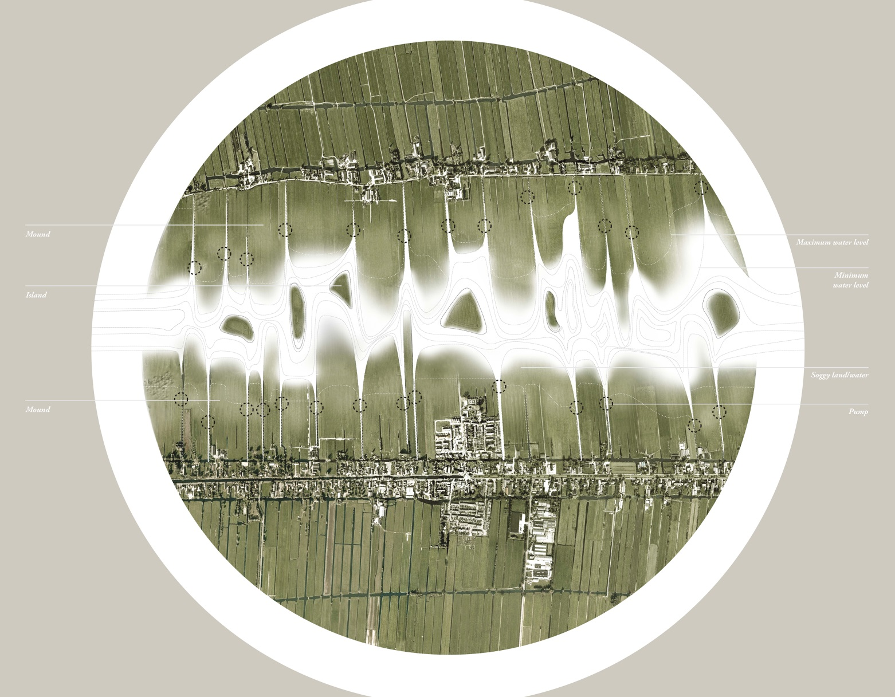
Image. 6: Peat polder “landscape grammar” in the Blue Heart: central weterings are turned into flexible water storage areas or boezem.

The necessary expansion of the boezem water storage system through the manipulation of existing water networks is more than a way to improve flood resilience: it could also serve to bolster local economies by creating a new “watery commons” that provides alternative sources of income for dairy farmers. The reorganization of this landscape necessitates a rethinking of the meaning of property as well as a return to the kind of cooperative negotiation that exemplifies the polder system. If multiple farmers come together to form cooperatives of 3-4 farms, they can collectively negotiate the shape of the mound that separates their farmhouses from the new wet zone at one end of their properties. Because this water level is variable – generally higher in the winter and generally lower in the summer, but with unpredictable spikes and drops based on regional conditions – the profile of the mound determines the extent to which they own “dry” property vs. “wet” property. The material for the mound comes from the dredged earth that is a result of the widening of the wetering. The process of negotiation between groups of farms and the government is rooted in the old “polder system”, which is founded in democratic collaboration; this might more accurately be called the “unpolder” system.

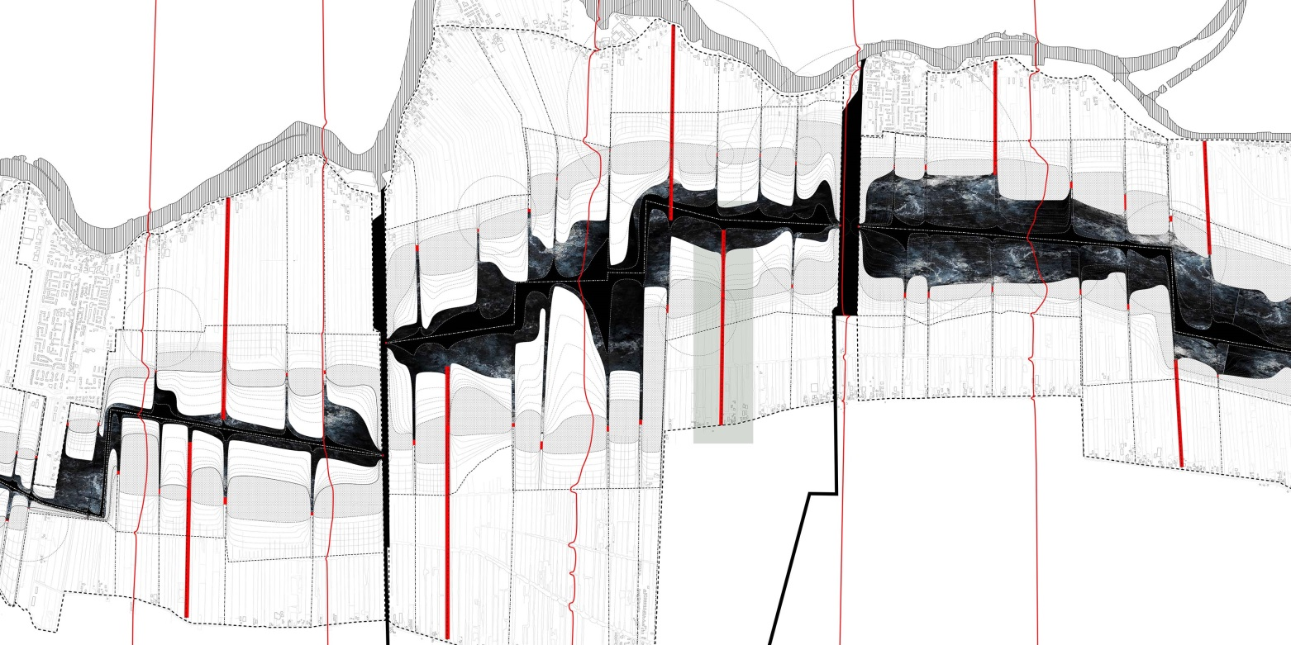
Image. 7: Carving space for water out of existing networks in the Krimepenrwaard.

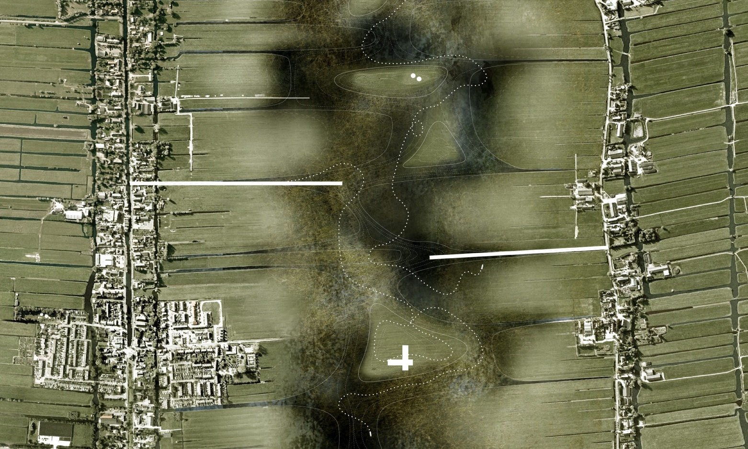
Image. 8: The new water storage area serves as a soggy commons.

It is both the establishment of cooperatives and the existence of a new wet-dry transect that provides new economic opportunities for farmers. In terms of dairy production, the formation of cooperatives would allow for the use of pooled resources and creates economies of scale, allowing farmers to compete with larger companies while retaining their independence. This may allow them to focus on alternative or niche markets as well as milk and cheese. The existence of the negotiated transect between wet and dry, moreover, opens up opportunities for income based on tourism and recreation as well as ecology (since the Dutch government does pay farmers directly for ecological services). For instance, canoeing through the Krimpenrwaard is a popular activity already; the creation of wider areas with more diverse vegetation and animal species could open up this landscape up to camping, fishing and other forms of recreation which could be monetized by farmers (and which is already occurring in other extremely wet agricultural areas).
In the future, a system of expanded weterings could cover much of the Krimpenerwaard and other historical agricultural polders, leaving urban strips and farms intact but radically changing how the landscape functions.

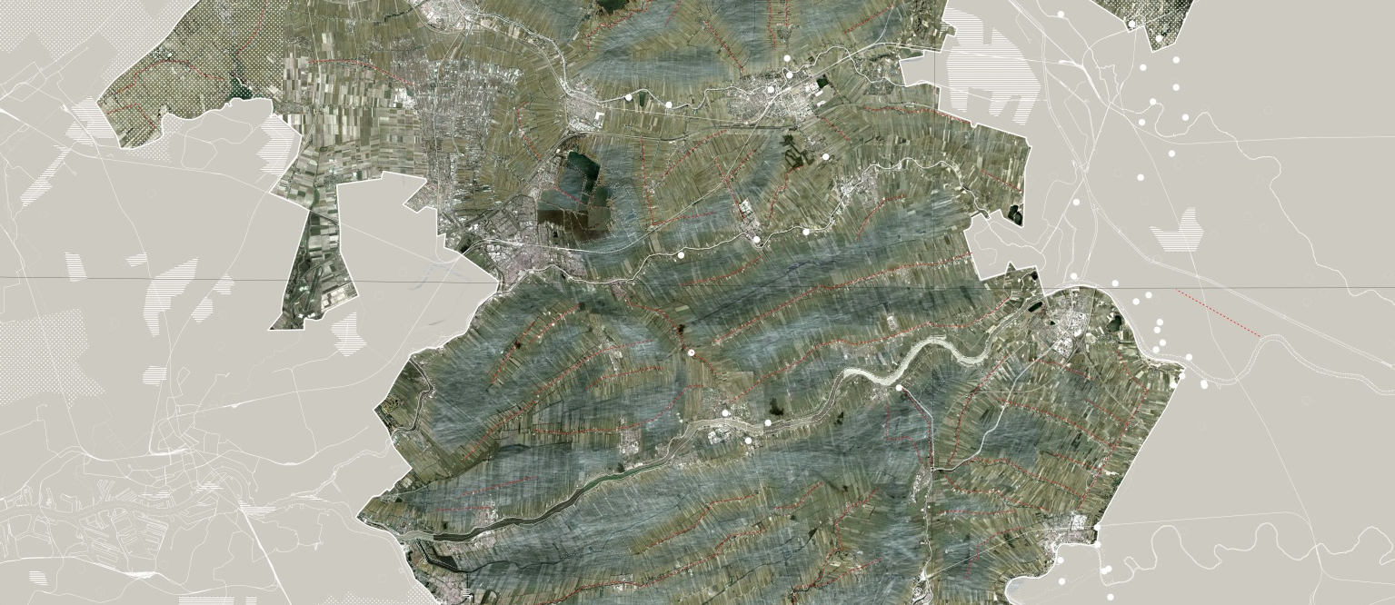
Image. 9: Over time, large areas of the Green Heart could become Blue in an expanded, interconnected soggy network.

SOGGY COLLECTIVES
The Blue Heart is a landscape-scale proposal with impacts that ripple into the architectural and human scales. It is important to recognize that the Dutch rural landscape’s iconic forms - the barn for dairy cows, the ditch, the windmill, the unique type of village urbanism organized around water canals, the dike – arose gradually out of a specific set of constraints dictated by the need to control and store water, as well as economic and political organization equally as shaped by water management. When those fundamental realities shift to create a new paradigm of flexibility and sogginess rather than hyper-management, it follows that the associated forms must also adapt. New forms reflect new environmental and economic realities, but they also produce a new iteration of the pastoral Dutch landscape imaginary.
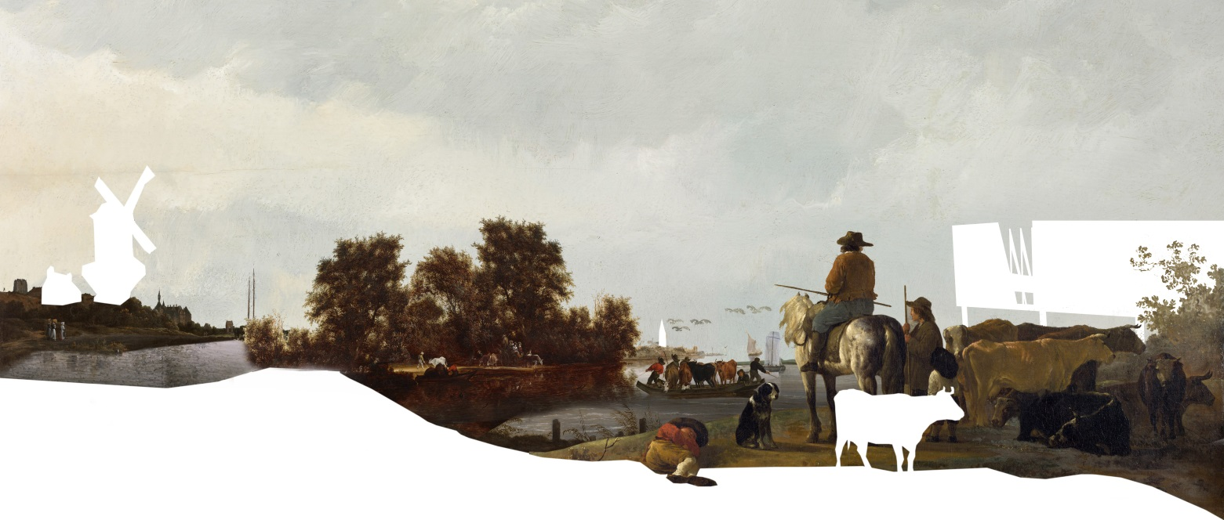
Image. 10: What is the image of the Blue Heart?
The Continuous Barn is a speculation on how one particularly significant icon of the Dutch pastoral landscape - the barn - could evolve to reflect the new paradigm of collective sogginess. Given the Blue Heart’s reorganization of agricultural plots into wet-dry transects that terminate in a new watery commons, the new building typology could allow farmers to effectively utilize this new landscape by enabling the occupation of this transition between wet and dry.
The Continuous Barn is a new typology: a long building that begins at the kadijk road, follows the gentle slope of the newly created mound to the pump (hovering over the new canal), and extends over the water in the new boezem. Following trends in organic farming that radically simplify and “dematerialize” barns into simple roof structures with no stalls, robotic milking and plenty of ventilation, the outer envelope of the barn could be nothing more than a rainscreen on trusses. Wood cladding wraps around the figure but splits to allow light and air to penetrate. The floor is hollow, allowing liquid waste from animals to flow down the slight slope into containers at one end. Animals are housed in several sleeping areas (sub-barns) within the Continuous Barn, but are allowed the freedom to walk up and down the structure and out onto the pastures.
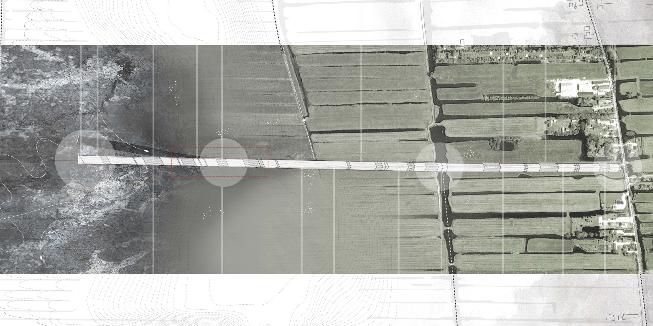
Image. 11: The Continuous Barn forms a transect between village road and the water

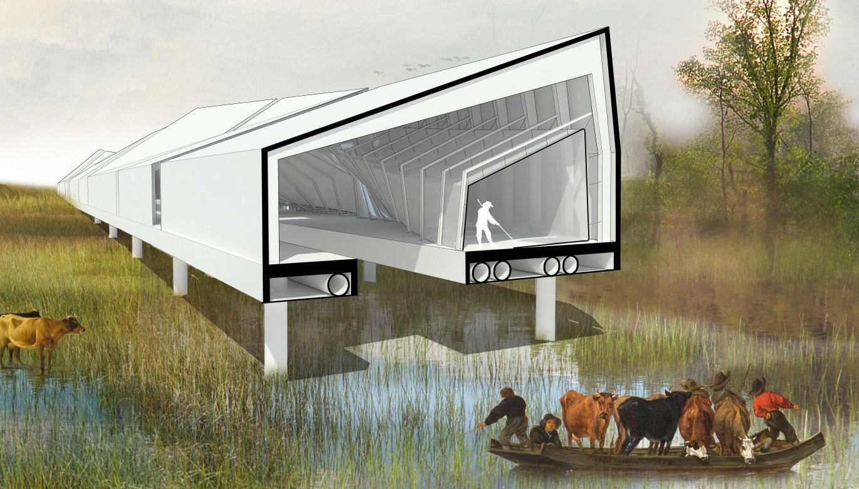
Image. 12: The section of the Continuous Barn brings together humans, animal and landscape in heterogenous assemblages

The “occupied transect” brings together farmers, cows, and visitors into a heterogenous assemblage that creates new relationships between people, animals, and the landscape, while condensing those actors into one long strip. The thermal requirements for humans are not the same as for cows; while cows generate enough heat to keep themselves warm at night, people generally require some form of insulation and climate control. The “human tube” is a separate thermal envelope that is inserted into the Continuous Barn and allows humans to share space with cows. The human tube penetrates, bisects and at times hovers above the barn, allowing for changed and closer relationships between cows and humans. It generates symbiotic relationships; for instance, guest accommodations in the wintertime are located above the barn, allowing the heat from cows to warm the human tube. Cow milking stations are located next to a milk bar. Manure pits are located underneath toilets.
The program of the Continuous Barn relies on the section as well as plan) for definition. The cow sleeping areas (sub-barns) are located mostly in zones with access to pasture - that is, where the Continuous Barn is all the same level as the ground. Human programs consist of functions carried out by workers (office work, sales, tours, farm labor, taking care of livestock) as well as recreational or tourist areas for visitors (a cheese market, guest accommodations, fishing and viewing platform, restaurant). Where the barn is closest to the road, it contains public functions like a storefront and gallery; where it hovers over the boezem it contains functions that cater to visitors coming from this waterway; and where it is closely ties to existing pasture it contains more worker spaces and functions. Important nodes within the Continuous Barn include the end that reaches the road (the old pastoral); the end which hovers over the water (the new pastoral); and the inflection point of the pump.

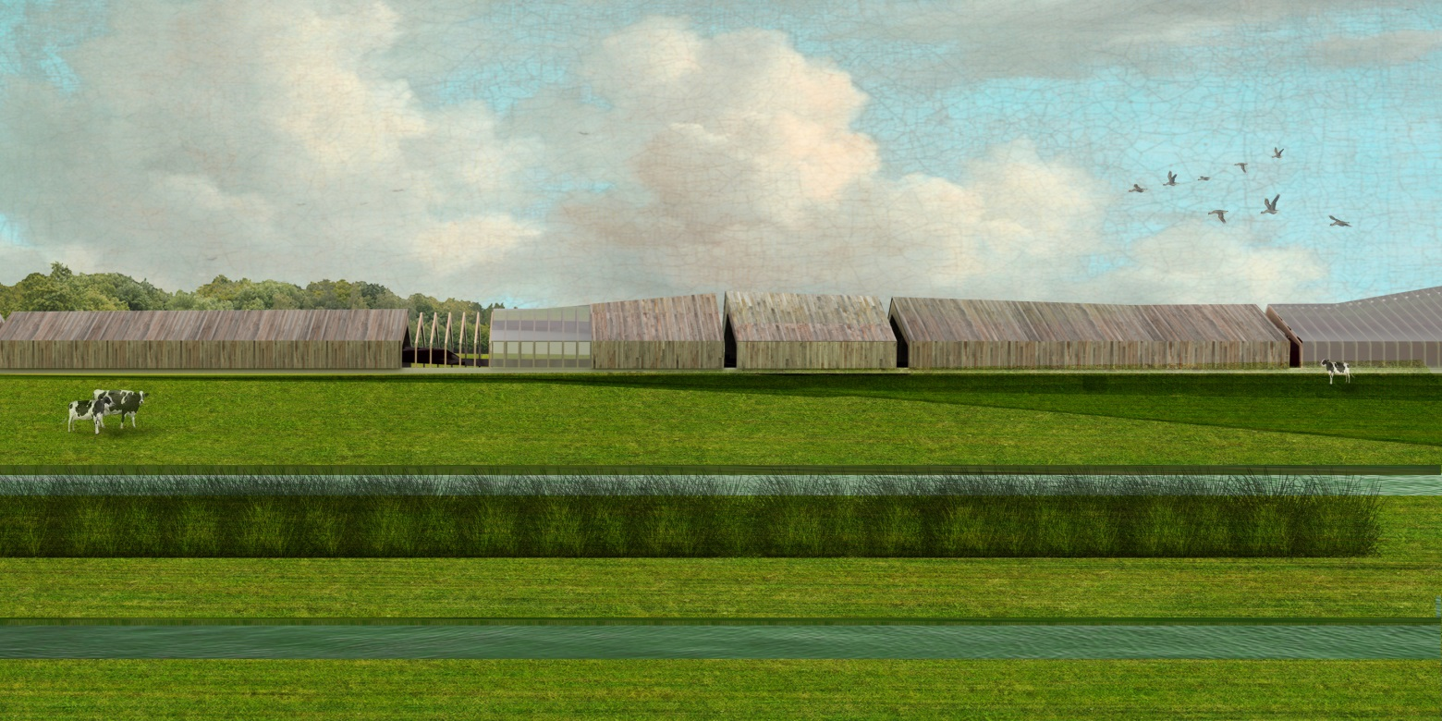
Image 13: Postcard from the Blue Heart, #1

Critical to the functioning of the Continuous Barn as a new building typology is the fact that it also reflects a different economic typology; a return to the spirit of collective entrepreneurialism that created the polder system and, with it, much of Holland. For farmers, the Continuous Barn is a shared space for income generation from cows and visitors alike, which benefits from the new wet landscape to create alternatives to corporatized scale dairy farming. For cows, it is a space that allows newfound freedom of movement and access to pasture. For tourists, it is a space that can be accessed either from the road or from the water and that offers leisure facilities, a resting stop on a canoe tour, or access to purchase local dairy and farm products. While the Blue Heart creates new soggy commons in the heart of the polders, the Continuous Barn brings together the actors which actually form the collective.

BLUE COMMONS, BLUE IMAGINARY
The Continuous Barn is a speculation on what an architecture of sogginess in the Blue Heart might look like, but it is also a typological shift to one of the oldest and most enduring forms in the Dutch pastoral landscape: the barn. What happens if this typological shift is applied to all the basic components of Dutch rurality? What is the soggy windmill, the soggy dike, the soggy village?

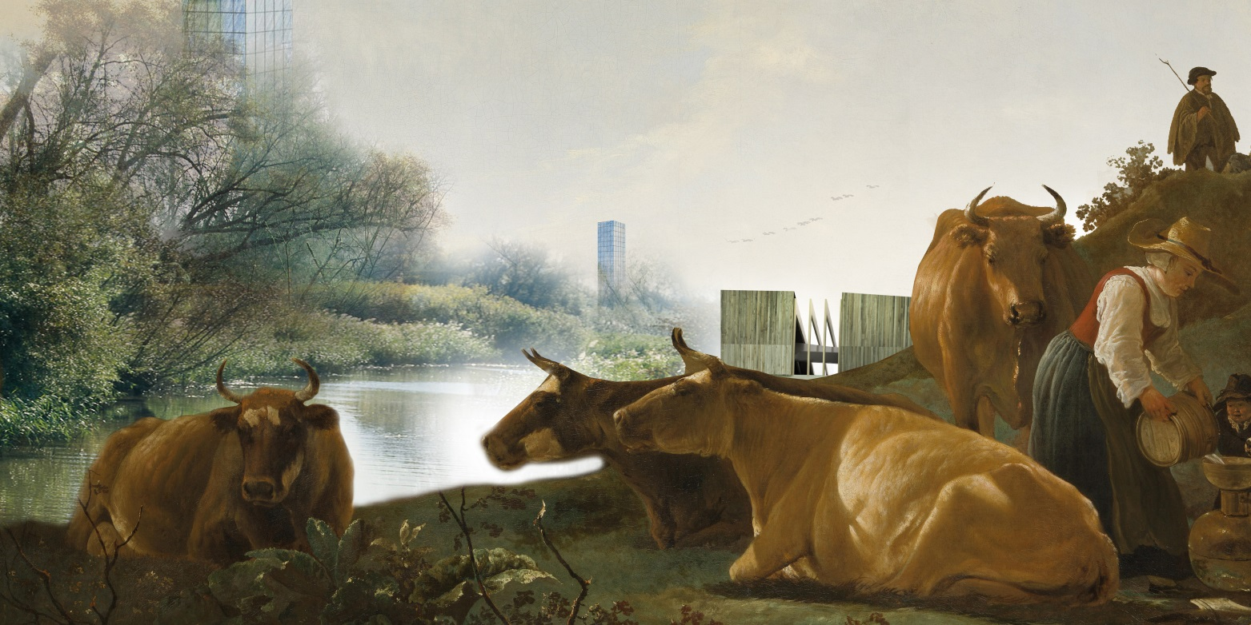
Image 14: Postcard from the Blue Heart, #2
The questions are interesting from purely a purely architectural point of view, but these shifts to the forms of Dutch rurality, more fundamentally, create entirely new representations, myths and imaginaries of the Dutch landscape that finally transcend Golden Age pastoral images. If today’s Google searches result in images that still evoke seventeenth-century pastoralism, what will tomorrow’s searches return? The Blue Heart landscape could form the basis for a more sustainable, more collective, and more equitable form of modern rurality.
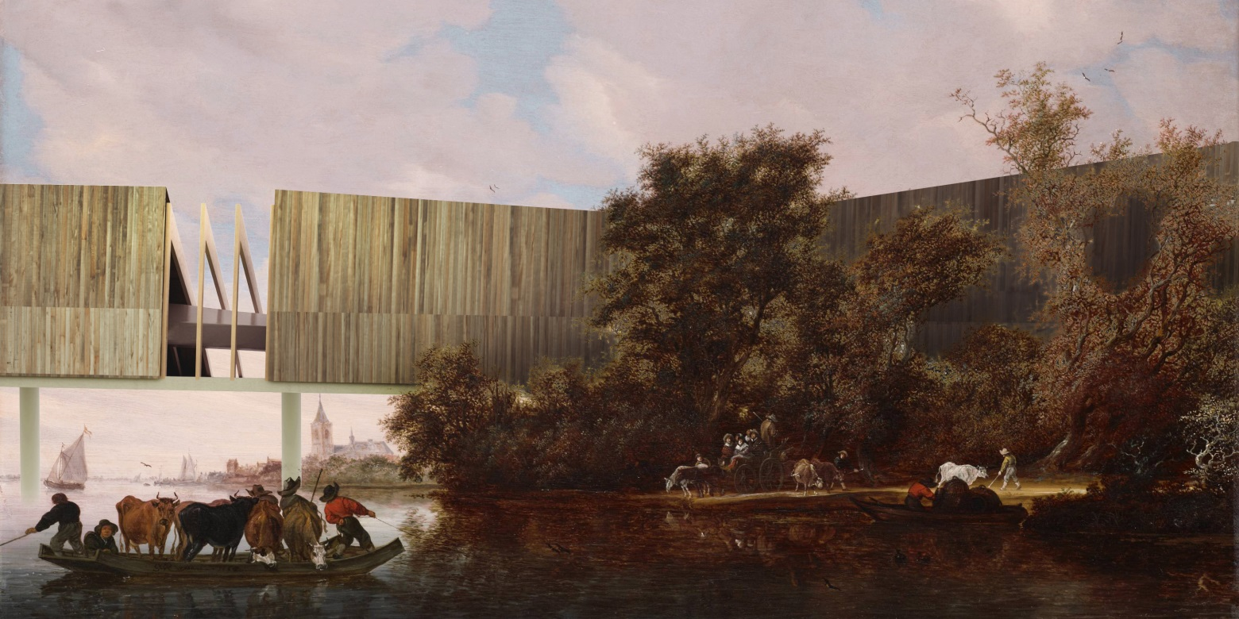
Image 15: Postcard from the Blue Heart, #3

